**TUGAS PENGANTAR PEMROGRAMAN**

**NAMA : RAHSYA ALFRENDIKA**

**NIM: 312510339**

**DOSEN: Agung Nugroho, S.Kom., M.Kom.**

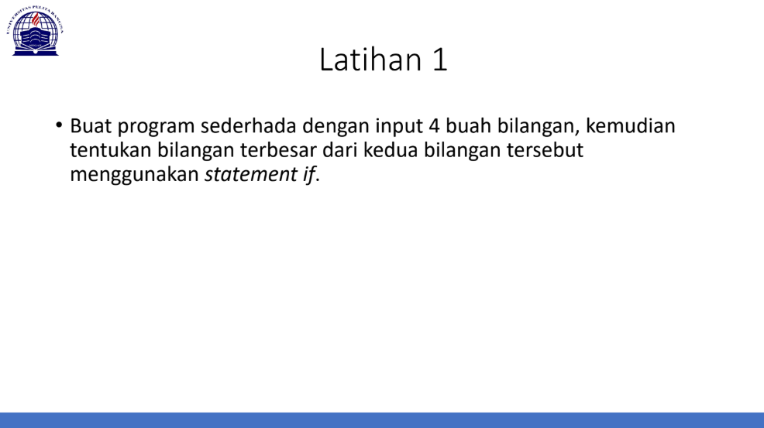

JAWABAN

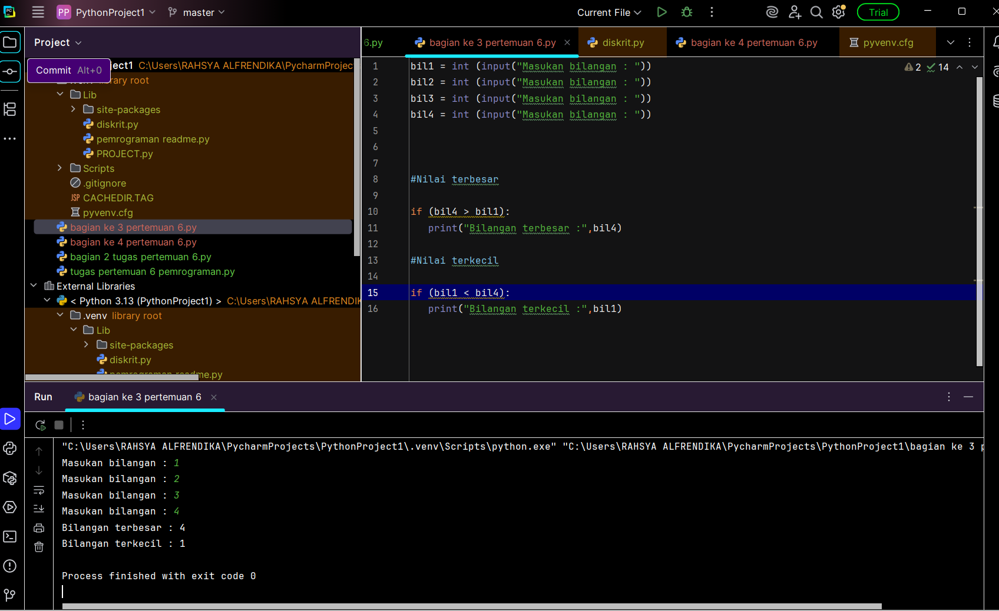

Soal perulangan

JAWABAN

